**Unit I**

**System Calls**

The interface between a process and an operating system is provided by system calls. In general, system calls are available as assembly language instructions. They are also included in the manuals used by the assembly level programmers. System calls are usually made when a process in user mode requires access to a resource. Then it requests the kernel to provide the resource via a system call.

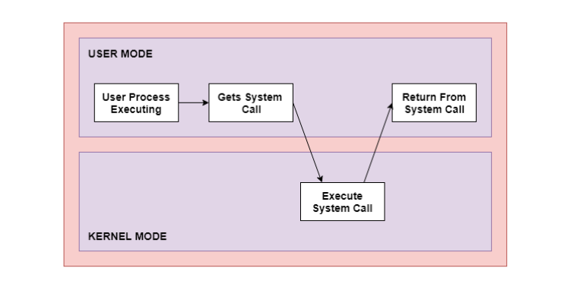

As can be seen from this diagram, the processes execute normally in the user mode until a system call interrupts this. Then the system call is executed on a priority basis in the kernel mode. After the execution of the system call, the control returns to the user mode and execution of user processes can be resumed.

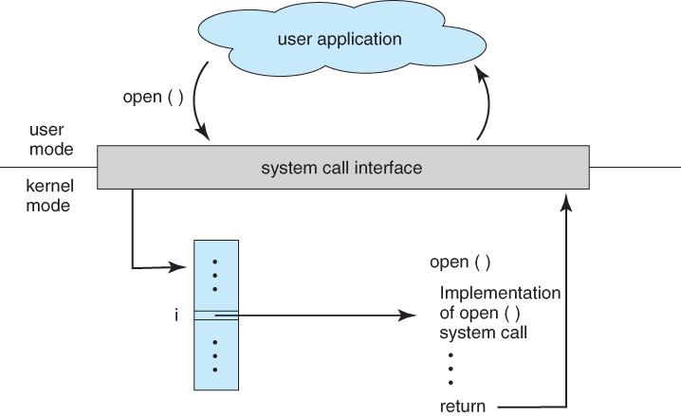

In general, system calls are required in the following situations −

* If a file system requires the creation or deletion of files. Reading and writing from files also require a system call.
* Creation and management of new processes.
* Network connections also require system calls. This includes sending and receiving packets.
* Access to a hardware device such as a printer, scanner etc. requires a system call.